**MULTIMEDIA PROJECT REPORT**

**Deadline:** Monday 13th 2015 1pm

|  |  |  |
| --- | --- | --- |
| **PROJECT TEAM** | | |
| **Student No** | **First Name** | **Surname** |
| **X14562027** | **Mark** | **Leonard** |
| **X14379546** | **Robbie** | **Jenkinson** |

**SMUGGLERS CAVE**

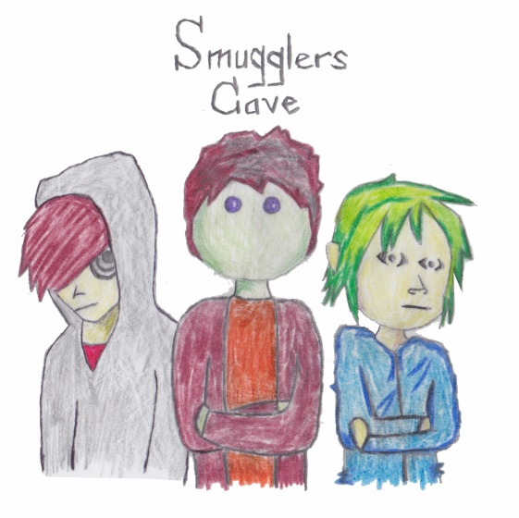

1. **OVERVIEW**

**Motivation for the Project:**

We decided to development an animated band because we felt there needs to be more animated bands and musicians in the world with the modern resources that are available to make them. Through the use of various multimedia software's characters and audio can be generated.

**Proposal:**

For this project we will be developing a website and various multimedia forms on the site for a fictional animated band. We will be using media forms such as sound, music videos and pictures.

**Differentiation:**

We intend to differ from other brands by being completely focused on multimedia and give the user an entertaining and enjoyable experience which will hopefully, in turn, make them come back and continue to enjoy our website, which is what a good website or brand should do.

We feel we have hit a niche in the musical industry with our animated band. We hope for people to notice our differentiation and brand which will enable it to be a success.

**Functional Requirements**:

Our functional requirements are the ability to create a virtual band and to play music fully through the use of multimedia tools such a fireworks, Animatron etc.

Our project will also give the user the option of interacting via social media such as Facebook, twitter and Instagram. There will also be links to photos, news and music of the virtual band including our animation videos for our virtual band. The project will also include interactive functioning games based on the bands characters for users to play.

**STORYBOARD / WIREFRAME**

**Early character development sketch:**

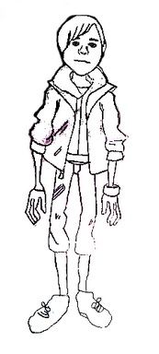

**Developed Characters. (Sketch by Mark Leonard)**



**Wireframe:**

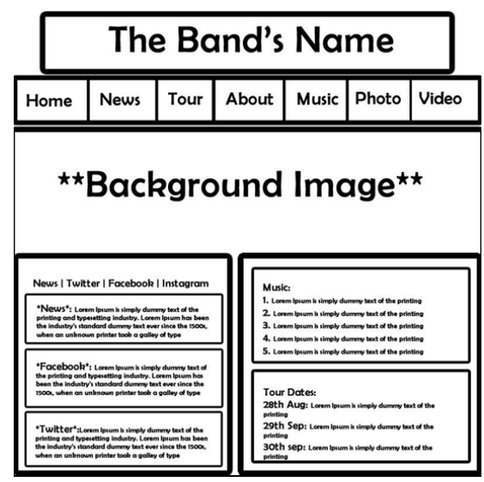

**RESEARCH**

For our Project we researched many animated music videos and musical websites to get an idea of what we should be doing and how we were going to do it. This research allowed us to set goals for the project and to recognise what work should be done. We recognised that the world is going the way of technology and everything these days is done by computer and internet, especially business and communications. Music being available online and Music being made online has sparked a massive interest in the industry, causing a lot of opportunities and money in music. We saw that this is the way music and technology is going and wanted to combine the two to make a virtual band. There are many animated bands that we researched such as The Gorillaz.

[1] “Gorillaz are an English virtual band created in 1998 by Damon Albarn and Jamie Hewlett. This band is fronted by four animated members: 2D (lead vocals, keyboard, and melodica), Murdoc Niccals (bass guitar), Noodle (guitar, keyboard, and backing vocals) and Russel Hobbs (drums and percussion). These members are completely fictional and are not personas of any "real life" musicians involved in the project. Their fictional universe is explored through the band's website and music videos, as well as a number of other media, such as short cartoons. The music is a collaboration between various musicians, with Albarn being the only permanent musical contributor. Their style is an amalgamation of genres, with influences including rock, alternative, Britpop, trip hop, hip hop, electronica, indie, dub, reggae and pop.”

We visited many music websites to get an idea of what we wanted our website to look like and what we wanted in our content. Many websites that we visited had content which included, Facebook, where they can share what the band is up to and updates of the band. Twitter, where they can tweet frequently about the band and followers can read them. And Instagram, where they can upload videos and pictures so their followers can see visually what the band is doing. Also on many websites were a link to the band’s music or a link to the bands iTunes where people can go and buy albums, songs for cheap prices etc.

Another big thing that we found on numerous bands websites were the tour dates they had announced and where they would be playing etc. Also there were links to tickets where people could pay to see them. From our research we found that bands were very good at advertising their music and communicating with fans and followers.

Your target customer & the problems you are solving:

The target market for our project are fans of music and/or animation of all ages. The project will combining these two media with other media’s such as photography, visual, audio, and interactive media. The customer will be able to use to site to view music videos of the band, interact through various media forms and play games.

Problems we will be solving is making bands websites more interactive for fans. Many of the bands websites we visited during our research lack user interaction. The majority of the sites just have simple things such as checking tour dates or buying merchandise, and not much else to offer the customer. This project will introduce far more multimedia into the website, something that very few bands have availed of in the modern technological world.

**PRODUCTION LOG**

The concept of our project is to develop a fully functioning website and animated band. We divided the workload between ourselves. Robbie tackled the HTML side of the project and website while Mark took on the animation side of the project, which is a massively important part as it is an animated band. To develop the website, Robbie used Dreamweaver, this allowed him to view and edit the design as he went along, and making sure that it was properly and looked good. Minor issues were had, for example, the input of animation and videos and also the use of tables and making sure their alignment was correct.

**Adobe Fireworks Elements**

Robbie’s role in image development was to develop a crest for the band on Fireworks, this is used also on the websites homepage and on the drum kit of the band. Mark developed the entire band on fireworks, this required a lot of hours and patience as each limb of a member of the band was a separate layer.

**Adobe Flash Elements**

Mark used Adobe Flash creating the Banner found on the homepage showing the characters and logo fading in.

**Online / Social Media Elements**

For our Social Elements, We made Twitter and Facebook pages for people who visit the website. We created links so people can go straight from the website to our social media pages and view videos, pictures, statuses and tweets.

**Responsive Website Elements**

Robbie used the grid system on our website so that any user that minimized the website could still use it effectively and not have to scroll a lot to see what they want to see.

**Other Digital Elements**

Robbie used Dreamweaver to create the website. The website contains three html pages, ‘Home’, ‘’Videos’ and ‘Biography’ The home page contains a banner made in Adobe Flash as well as links to the bands social media pages and tours dates. The video page contains two videos from the band, both the same song but different videos and the Biography page contains the background story of the band and its individual members.

Mark used various forms of software to create the band’s music videos. The first video seen on the ‘Videos’ page was made using Animatron, each of the characters limbs and instruments were created in Photoshop and Fireworks all as separate PNG files.

The second video seen was made using ‘Movie Maker’ from Windows, it combined the video from Animatron which was recorded and cropped through ‘CamStudio’ software, this was combined with a Blender animation Mark made. Through Windows ‘Movie Maker’ these two animations were combined as well as opening and closing credits, resulting in the finished video.

1. **PROJECT TEAM**

We identified what each of our strengths were in order to achieve a good website/Animation. We identified that Mark is a very skilful animator and enjoys creating animations whereas Robbie enjoys coding websites and designing web pages, so we both agreed to do what we were strongest at. Both team members did what was required from their part of the project. Naming the band and naming band members was a bit of an issue.

1. **CONCLUSION**

Looking back, Mark would have preferred to give himself more time to master Blender animation and preferably have it in a higher quality video, also the Animatron animation contained a few minor faults that Mark couldn’t quiet fix.

Robbie could have utilised his time more efficiently in order to make the website look more attractive and make it responsive.

Overall, we are both satisfied, however, we would have liked to put more time into this project to make it that bit better.

1. **REFERENCES**

[1] Gorillaz - Wikipedia, the free encyclopedia. 2015. Gorillaz - Wikipedia, the free encyclopedia. [ONLINE] Available at:<http://en.wikipedia.org/wiki/Gorillaz>. [Accessed 13 April 2015].